A201 Exercise—Debugging

AUTHORIZED RESOURCES: your instructor, your course notes, course materials and other cadets (but do not copy any of another cadet’s work)

Background:

We’ve given you some tools to debug code in Matlab. Here’s your chance to put some of those tools to work.

In this exercise, you will be given a Matlab function that has errors in it.

The function you’ll start with is called badintro.m. For a set of five initial velocities and angles of projectiles, it is supposed to calculate the: a) flight time, b) maximum height reached and c) maximum horizontal distance traveled.

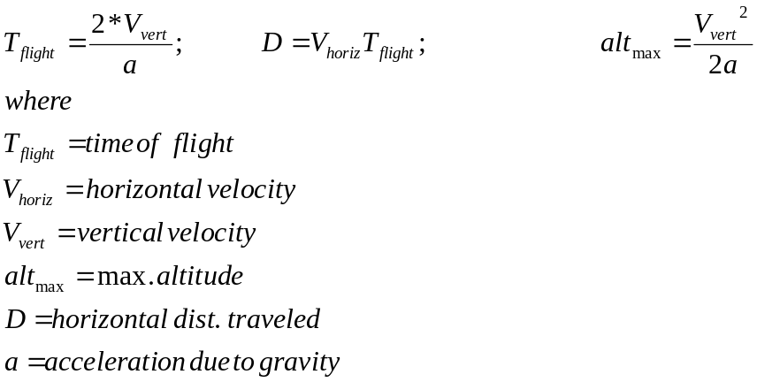

You may use any method to calculate test cases.

Tasks:

- Starting with the m-file badintro.m, find all the errors in the program and debug it so it provides reliable values for the intended calculations.
- Determine a test case to validate the answer for at least one of the five cases.

Note: You may fulfill these requirements by having the instructor verify your work by any of the following means:
- Signoff by viewing during class assigned -or-
- Bring hard copies to class for signoff

  - Documented Code

  - Test Case Results for the five cases

  - Hand Calculations for One of the Cases

